**Project-2 Report**

**Ques 1:**

Since the data set has **less observations** we used **Cross Validation Method** to partition the dataset into 5 folds. 4-folds used for Training and 1-fold for testing.

**Ques 3: Democratic Votes (Linear Regression)**

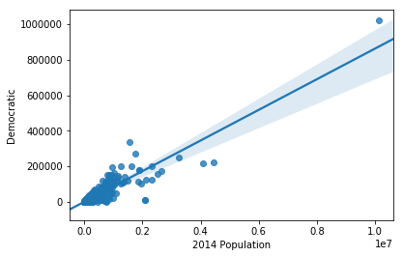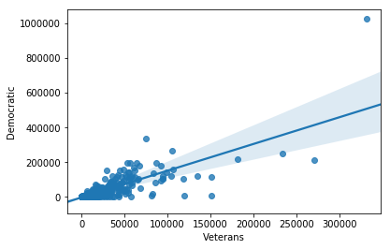

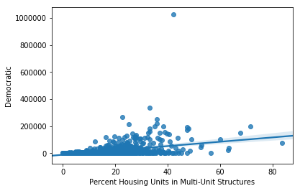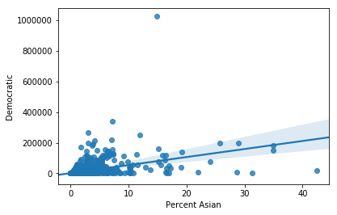

|  |  |
| --- | --- |
| Democratic Votes Vs 2014 Population:  R squared Value  **0.7676021019051809** | Democratic Votes Vs Veterans:  R squared Value  0.6182486015453023 |
| Democratic Votes Vs Percent Housing Units:  R squared Value  0.22689551351538348 | Democratic Votes Vs Percent Asians:  R squared Value  0.20545255049235156 |

Out of the above Variables the Linear model with **“2014 Population”** as the independent variable best represents the proportion of variance of the “Democratic Votes” Variable.

**Selecting Variables**: Used Lasso Regression to find the attributes having high coefficients and tried each of those as independent variable.

**Ques 4: Democratic Votes (Multiple Regression)**

|  |  |  |
| --- | --- | --- |
| **Variable Type** | **Variables** | **Adj R Squared Value** |
| ALL Variables in demographics | '2014 Population', 'Percent Under 5 Years',  'Percent Under 18 Years', 'Percent 65 and Older',  'Percent Female', 'Percent White', 'Percent Black or African American', 'Percent American Indian and Alaska Native', 'Percent Asian', 'Percent Native Hawaiian and Other Pacific Islander',  'Percent Two or More Races', 'Percent Hispanic or Latino', 'Percent White, not Hispanic or Latino', 'Veterans', 'Percent Foreign Born', 'Percent High School or Higher', "Percent Bachelor's Degree or Higher", 'Median Household Income' | 0.7603270121122873 |
| Population and Races | '2014 Population', 'Percent White', 'Percent Black or African American', 'Percent American Indian and Alaska Native', 'Percent Asian', 'Percent Native Hawaiian and Other Pacific Islander', 'Percent Two or More Races', 'Percent Hispanic or Latino | 0.7667590644612492 |
| Combination | '2014 Population', 'Percent White', 'Veterans' | 0.7705446070199521 |
| Combination | '2014 Population', 'Percent Under 18 Years', 'Percent Female', 'Percent White', 'Veterans' | **0.7757726373543314** |
| Population and Gender | '2014 Population', 'Percent Female' | 0.7686740692176488 |
| Population and Degree | '2014 Population', 'Percent High School or Higher', "Percent Bachelor's Degree or Higher" | 0.7673850267089972 |

From the above table the best attributes that gave the highest adjusted R square value for the test dataset using **cross validation with 5 folds** were **'2014 Population', 'Percent Under 18 Years', 'Percent Female', 'Percent White', 'Veterans'** with **77.6%** adjusted R square value.

**Selection of Variable:**

Tried multiple combinations of demographic attributes based on categories such as Race, Gender, Degree, Population etc

Used Lasso Regression to find the attributes having high coefficients and tried those as combination of variables.

**Ques 5: Republican Votes (Linear Regression)**

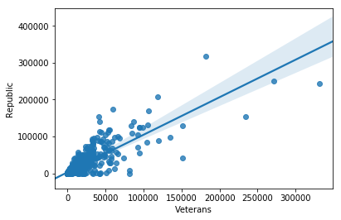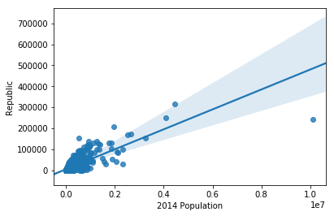

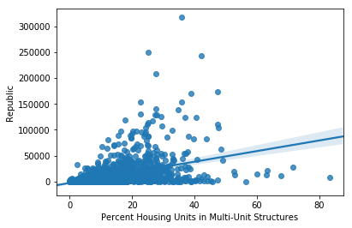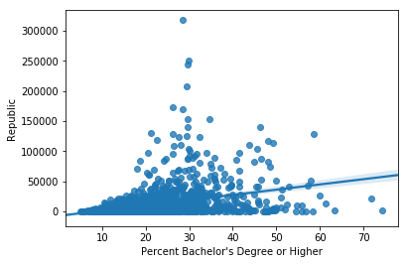

|  |  |
| --- | --- |
| Republican Votes Vs Veterans:  R squared Value  0.688409212246721 | Republican Votes Vs 2104 Population:  R squared Value  0.4419662405327318 |
| Republican Votes Vs Percent Housing Units:  R squared Value  0.1879172662191234 | Republican Votes Vs Percent Bachelor’s Degree:  R squared Value  0.13124021344937936 |

Out of the above Variables the Linear model with **“Veterans”** as the independent variable best represents the proportion of variance of the “Republican Votes” Variable.

**Selecting Variables**: Used Lasso Regression to find the attributes having high coefficients and tried each of those as independent variable.

**Ques 6: Republican Votes (Multiple Regression)**

|  |  |  |
| --- | --- | --- |
| **Variable Type** | **Variables** | **Adj R Squared Value** |
| ALL Variables in demographics | '2014 Population', 'Percent Under 5 Years',  'Percent Under 18 Years', 'Percent 65 and Older',  'Percent Female', 'Percent White', 'Percent Black or African American', 'Percent American Indian and Alaska Native', 'Percent Asian', 'Percent Native Hawaiian and Other Pacific Islander',  'Percent Two or More Races', 'Percent Hispanic or Latino', 'Percent White, not Hispanic or Latino', 'Veterans', 'Percent Foreign Born', 'Percent High School or Higher', "Percent Bachelor's Degree or Higher", 'Median Household Income' | 0.5973249554223555 |
| Population and Races | '2014 Population', 'Percent White', 'Percent Black or African American', 'Percent American Indian and Alaska Native', 'Percent Asian', 'Percent Native Hawaiian and Other Pacific Islander', 'Percent Two or More Races', 'Percent Hispanic or Latino | 0.39305314200845354 |
| Combination | 'Percent Female', 'Veterans', 'Percent Two or More Races', "Percent Bachelor's Degree or Higher", 'Percent Under 18 Years' | **0.7032299624779152** |
| Combination | '2014 Population', 'Percent Under 18 Years', 'Percent Female', 'Percent White', 'Veterans' | 0.6883803543923029 |
| Population and Gender | '2014 Population', 'Percent Female' | 0.4479955836316444 |
| Population and Degree | '2014 Population', 'Percent High School or Higher', "Percent Bachelor's Degree or Higher" | 0.4603491035109062 |

From the above table the best attributes that gave the highest adjusted R square value for the test dataset using **cross validation with 5 folds** were **''Veterans', 'Percent Female', 'Percent White'** with **70.33%** adjusted R square value.

**Selection of Variable:**

Tried multiple combinations of demographic attributes based on categories such as Race, Gender, Degree, Population etc.

Used Lasso Regression to find the attributes having high coefficients and tried those as combination of variables.

